Project documentary

1st Due date (Demo): 24th July. 2020.

2nd Due date: 26th Aug. 2020.

To-Do’s List:

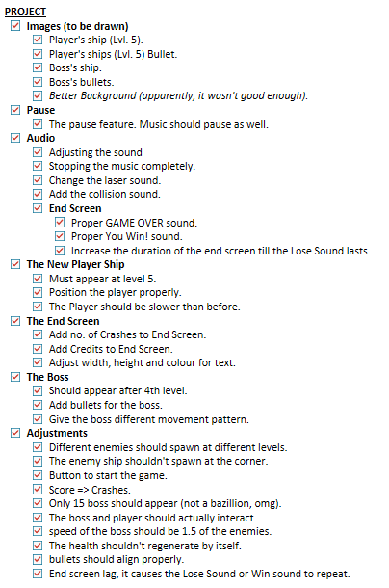

3rd Due date (Final): 27th October

To-Do’s List:

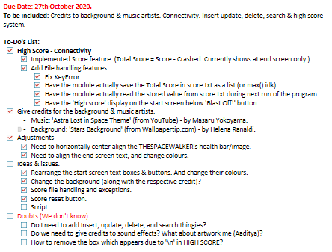

**Links:**

Background:

<https://www.wallpapertip.com/wpic/hixh_stars-background/>

Music:

[ASTRA LOST IN SPACE OST - Main Theme | Masaru Yokoyama](https://www.youtube.com/watch?v=1UYcCrDSM_g)

**Behind the Scenes:**

Original help for saving highscore in python:

<https://stackoverflow.com/questions/16726354/saving-the-highscore-for-a-python-game>.

File Handling help:

<https://stackoverflow.com/questions/82831/how-do-i-check-whether-a-file-exists-without-exceptions>

<https://www.geeksforgeeks.org/how-to-delete-data-from-file-in-python/>

Class PPTs referred to:

"File Handling"

"Numbers & Strings"

Online help regarding class PPTs:

<https://docs.python.org/3.8/library/shelve.html>.

<https://www.programiz.com/python-programming/dictionary>.

My Questions asked online on Stack Overflow:

1. <https://stackoverflow.com/questions/63257873/space-invaders-loading-images>
2. <https://stackoverflow.com/questions/64460690/space-invaders-high-score-keyerrors?noredirect=1#comment114070538_64460690>.

Inspirations & other online references:

[Pygame Tutorial - Creating Space Invaders](https://www.youtube.com/watch?v=Q-__8Xw9KTM)

[Game Development in Python 3 With PyGame - 1 - Intro](https://www.youtube.com/watch?v=ujOTNg17LjI)

[Python / Pygame Tutorial: Creating multiple stages in a game](https://www.youtube.com/watch?v=j9yMFG3D7fg)

[Game Development in Python 3 With PyGame - 14 - Button Function](https://www.youtube.com/watch?v=kK4xhHr1QeQ)

[Game Development in Python 3 With PyGame - 12 - Button interaction](https://www.youtube.com/watch?v=1hlaMPzAUZ0)

Tools used along the way:

MS Paint & Paint 3D

Audacity [All sound effects are from random YouTube videos.]

Detailed credits, stories, incidents, problems faced along the way, etc:

All artwork & graphics done by Aaditya Sharma.

Designs & ideas by Aaryan & Aaditya Sharma.

All sounds, music & sources, found and edited by Aaryan Sharma.

Coding:

Classes, functions, positioning, file handling, adjustments & decor: Aaditya Sharma (Mainly).

Movements, var handling, error corrections, texts, objects, ideas: Aaryan Sharma (Mainly).

At one point, due to not having experienced with wave lengths (i.e. how many ships appeared at once and for now long), we ended up making 10 ships, every second, across the entire width of the screen, effectively crashing the program. What's more, that was on level 5, and we couldn't damage those ships, but they could!

Because of how the laser system works, we couldn't just create a variable, name it score, and make it so that whenever the laser collided with the enemy, it would increase by 1. At first, we spent whole 2 weeks, trying to figure out how to implement it, eventually forgetting about it, and added Crashed instead, showing how many times the ship crashed into an enemy ship.

Since we were now forced to add a score, we gave another go at it. It at first started in a similar fashion, both of us already frustrated on how to do it. Eventually calling quits and almost giving up. We later got the idea that instead of having the score based on how many enemies a player destroyed, let it be on passing each level, so +20 points at each level, having a maximum of 100 points at the end of the game. But now the problem was the highscore.

On 22nd Oct. 2020, Aaditya posted the issue we were face with on Stack Overflow, after some back and forth questioning, he found out the problem was that the score variable wasn't being saved on the file. Not knowing what to do, we were still stuck.

On 24th Oct. 2020, 3 days before submission date, we were given an assignment for the practical file (due 26th). Aaditya, tried attempting the first question, and realized that he doesn't know how to solve it, so referring to ma'am's whatsapp msg. that there'll be questions on csv & binary files, he tried studying them first from the class PPTs. He ended up mistakenly opening 'File Handling' PPT instead of 'CSV Files' and realized that this is something that he can use to solve his problem in the project!

We were originally due on 19th October 2020, I was informed so on 12th. I ended up not working till 17th October, and then extended the due date a week further (later realized Mon. is a holiday, so +1 more day!).